Title (All Papers in Microsoft Word *.doc without page numbers)

(Font: Arial, Style: Bold, Size: 12, Alignment: Center)

2 Lines Space (Font: Arial, Size: 10)

1st Author: Title Name (Style: Italic, Alignment: Right)

Email address (Style: Italic, Alignment: Right)

2nd Author (same affiliation): Title Name (Style: Italic, Alignment: Right)

Email address (Style: Italic, Alignment: Right)

Affiliation Institution, Country (Style: Regular, Alignment: Right)

3rd Author (different affiliation): Title Name (Style: Italic, Alignment: Right)

Email address (Style: Italic, Alignment: Right)

Affiliation Institution, Country (Style: Regular, Alignment: Right)

2 Lines Space (Font: Arial, Size: 10)

**ABSTRACT:**  (Font: Arial, Size 8, Alignment: Left, Indent: 2.54 cm = 1”)

2 Lines Space (Font: Arial, Size: 10)

**Major Heading (All Caps, Font: Arial, Style: Bold, Size: 10, Alignment: Left)**

1 Line Space (Font: Arial, Size: 10)

Text Body (Font: Arial, Size: 10, Alignment: justified)

1 Line Space (Font: Arial, Size: 10)

**Major Heading (All Caps, Font: Arial, Style: Bold, Size: 10, Alignment: Left)**

1 Line Space (Font: Arial, Size: 10)

1st level Sub Heading

1 Line Space (Font: Arial, Size: 10)

Text Body (Font: Arial, Size: 10, Alignment: justified)

2nd level Sub Heading (Font: Arial, Style: Italic, Size: 10, Alignment: Left)

Text Body (Font: Arial, Size: 10, Alignment: justified)

1 Line Space between Paragraphs (Font: Arial, Size: 10)

Text Body (Font: Arial, Size: 10, Alignment: justified)

Figure 1: (Font: Arial, Style: Bold, Size: 10, Alignment: Left, Embed figures at appropriate position in text)

Table 1: (Font: Arial, Style: Bold, Size: 10, Alignment: Left, Embed figures at appropriate position in text)

1 Line Space (Font: Arial, Size: 10)

REFERENCES (All Caps, Font: Arial, Style: Bold, Size: 10, Alignment: LEFT)

1 Line Space (Font: Arial, Size: 10)

Format References (Hanging Indent 1.5 cm Font: Arial, Style: Regular, Size: 10, Alignment: left), do not use a space between references.

**Additional rules:**

Do:

* use Paper Size: A4
* use Margins: 2.54 cm (1”) at all sides
* use the prepared format templates

Do not:

* submit more than 8 pages
* include page numbering
* include header numbering
* use footnotes
* use automatic references
* other formats than the prepared ones

Example for Paper Submission – International FEFLOW User Conference

Peter Schätzl

[feflow2015@dhigroup.com](mailto:feflow2015@dhigroup.com)

DHI-WASY GmbH, Germany

**ABSTRACT:** This example shows the format requirements for paper submission for the International FEFLOW User Conference 2009.

INTRODUCTION

This is the introduction.

It consists in two paragraphs.

PROBLEM DEFinition

The production of conference proceedings requires consistent formatting of all papers. To be able to prepare the proceedings within a very short time frame, DHI-WASY depends on your collaboration. Please prepare your paper as thoroughly as possible, following our guidelines!

Format definitions

Most important: Please use the predefined paragraph formats in this document for your paper preparation. Do not use other than the defined formats.

Figures

You may include greyscale and/or color images in your paper.

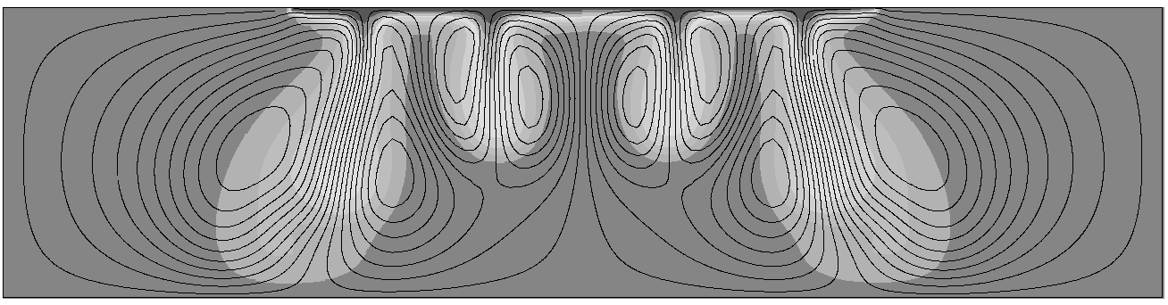

Figure 1: Grayscale and colored figures

Tables

Tables make a paper more readable. Please include them at a suitable location in the text.

|  |  |  |  |
| --- | --- | --- | --- |
| Format | Font | Font size | Font style |
| Table | Arial | 10 | bold |

Table 1: Table footers use the format ‘Table’

SUMMARY

If you have questions while preparing your paper, please contact us at [feflow2015@dhigroup.com](mailto:feflow2015@dhigroup.com). We would rather help you before you submit than have to send back a paper that does not fit the format.

REFERENCES

Magri, F., U.Bayer, V. Clausnitzer, C. Jahnke, H.-J. Diersch, J. Fuhrmann, P. Möller, A. Pekdeger, M. Tesmer and H. Voigt, Deep reaching fluid flow close to convective instability in the NE German basin - results from water chemistry and numerical modelling, Tectonophysics 397 (2005), 5-20

ACKNOWLEDGEMENTS

The template development has been funded by DHI-WASY GmbH, Berlin.